|  |  |  |
| --- | --- | --- |
| University of Plymouth | - | School of Engineering, Computing, and Mathematics |

**Final Report**

**COMP3000**

**Computing Project**

**2022/2023**

**ChessAI**

**A Chess Practice Tool**

Callum Reece Organ

10693074

BSc (Hons) Computer Science



### **GitHub Repository**

The repository for this project has been split into *Documentation* and *Code*, under their respectively named folders. The repository can be accessed at the following link:

* <https://github.com/ORG4N/ChessAI>

### **Word Count**

The total word count of this report is:

### **Abstract**

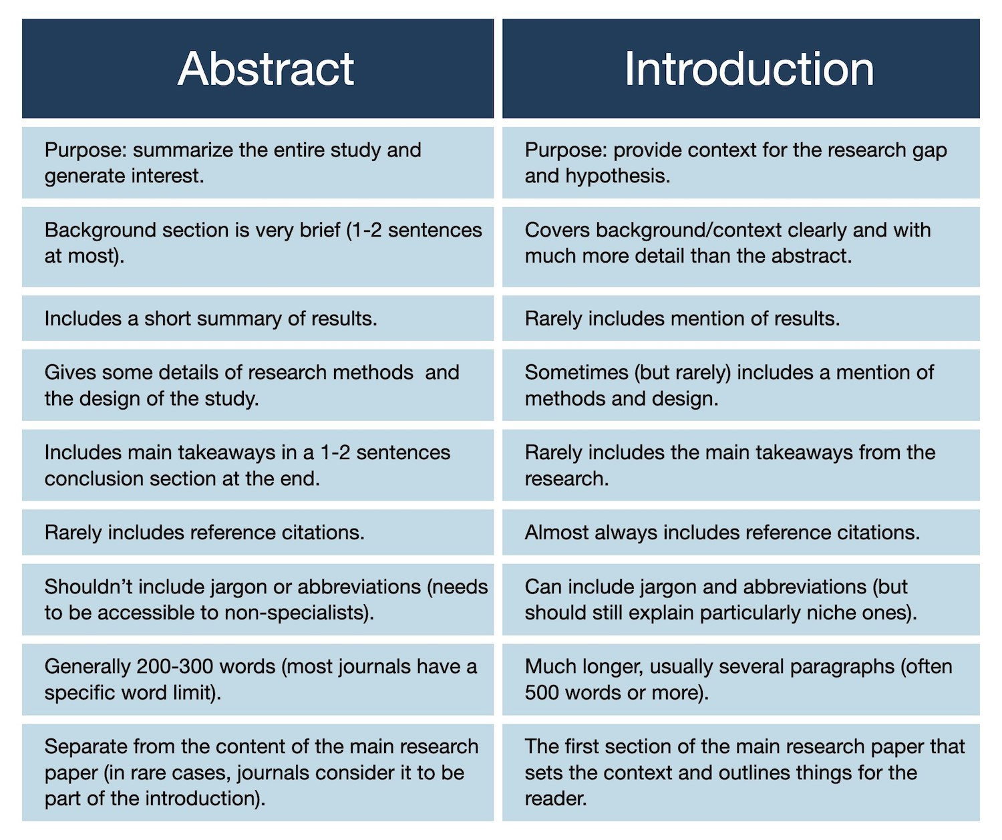

**Table of Contents**

**GitHub Repository** 2

**Word Count** 2

**Abstract** 2

**1. Introduction** 4

**2 Background** 4

**2.1 Literature Review** 5

**2.1.1 Existing Applications** 5

**2.1.2 Technology** 6

**2.1.2 Conclusion** 6

**3. Requirements** 8

**Chosen Development Technologies** 8

**Legal, Social, Ethical, and Professional Issues** 8

**4. Project Management** 8

**Method of Approach** 8

**5. System Architecture, Design, Implementation** 8

**6. Development and Stages** 8

**7. Testing** 8

**8. Output Documentation** 8

**9. End of Project Report** 8

**10. Project Post-Mortem** 8

**11. Conclusion** 8

**12. References** 9

**13. Bibliography** 9

**14. Appendices** 10

**14.1 Project Initiation Document** 10

14.1.1 Project Vision 10

**14.1.2 Project Goals** 10

**14.1.3 Project Objectives** 10

**14.1.4 Critical Success Factors** 10

### **1. Introduction**

* First section… literature review… existing applications… technologies that they use… benefits of these technologies…
* Second section… background of Chess AI
* Third section… requirements… discussion of technology… issues
* Fourth section… project management… sprint planning… agile approach… biweekly meetings.. sprint retrospection
* Fifth section… system architecture, design, implementation steps… diagrams
* Sixth section… development in sprints/stages
* Seventh section… testing… test preparation… development testing… user testing…
* Eighth section… end of module report… detail changes between start and now of requirements… completion of main features… recommendations in future development.
* Ninth section… post mortem… criticise technologies, approach, testing, individual performance…
* Tenth section… Conclusions… personal ideas on the project… conclude report…

### **2 Background**

Learning Chess can be a daunting adventure for some individuals, but this is merely a stigma that has been fabricated by the stereotype that Chess is a game for only intelligent people, and that to play Chess a person must be fully committed to learning a game that is perpetuated as complex. However, as with any other game or sport, Chess can be played casually, and indeed without knowledge of strategy.

The main method of learning a game or sport is through a repetitive cycle of practice and revision. For example, athletes in physical sports must perfect their form by repeatedly going through new experiences and experimenting and then ultimately deciding whether those experiences were positive or negative. This act of building knowledge via experience is otherwise known as practice. Within the game of Chess this is applied when a player moves a piece and then realises that a positive effect has occurred wherein they take an opponents piece or win via checkmate. Likewise, a player may realise that a move has negative consequences, and they allow the enemy to gain an advantage over them.

The ChessAI application provides this environment within which a user can develop their Chess skills as it provides them a range of computer-operated opponents to select from, with each representing a different skill level of Chess. ChessAI is an application ideally suited for beginner and novice chess players. Through the app, these players can play games against AI opponents that aren’t designed to play the best possible move, but rather determine which move the average player of the AI’s designated skill level. Therefore, new players can play against a simulation of a human player without the pressure of playing against a real human player.

In Chess, ‘*elo rating*’ is the value which represents the skill level of a player (*Elo rating system - Chess Terms, no date*). This value can increase or decrease, which is determined by the outcome of each game they play. ChessAI uses the elo rating system to classify the different computer opponents. Each AI model is trained on the data of players in different elo brackets, ranging from between 1100 to 1900. Within the elo system a higher number represents a higher level of skill.

The idea of implementing Artificial Intelligence within Chess is not revolutionary. Different applications do exist and lots of new applications are in the process of being created. The following Literature Review investigates these solutions.

### **2.1 Literature Review**

This Literature Review was undertaken to answer two research questions:

* Which solutions currently exist within the Web for persons to learn Chess and develop their skills?
* Which technologies are currently widely employed to implement Artificial Intelligence within Chess?

The first section of this review investigates the first question, whereas the second section explores the second question. Answering these questions and carrying out this review highlighted issues with current applications that the Chess AI can innovate upon as well as differentiate itself and tap into a much more specific segment of the Chess community.

### **2.1.1 Existing Applications**

The biggest contenders within the Chess community are Chess.com and Lichess. These two platforms both allow users to play Chess in a manner of ways. Common features that both these applications share is:

* Player vs Player.
* Player vs Computer.
* Casual, non-traditional game modes.
* Puzzles.
* Lessons to learn all about Chess (rules, pieces, openings, advice).
* Forums and Chess news.
* Tools to review moves made and highlight blunders.

These platforms are not just platforms that enable users to play Chess but encourage the community to interact with each other and get involved within discussions via the forum and in-game chat box and friend functionality. These platforms can be described as social medias, with Chess as the common theme.

Within both applications, post-game analysis features are implemented that allow players to review the game that they just played. Both applications use the Stockfish engine to evaluate the board position which returns what is perceived to be the best possible move, as well as evaluating the move that the player has made to determine whether it is a blunder or perfect move.

**Limitations**

These two applications’ limitations are very few as these are global platforms used by millions of active users (*Rapid leaderboard - chess rankings, no date*) each month. However, whilst both sites have a great sense of community, they do not sufficiently focus on the individual user. Within both applications it is not easy for the user to find their statistics. The focus of these platforms is to simply play Chess and win or lose. Within these applications it is difficult to monitor progress, aside from seeing the elo rating increase or decrease.

Also, Chess.com is designed around its membership scheme. Some of the features most significant in developing a player’s proficiency are hidden behind this paywall and access is limited. This paywall limitation prevents players who want to get better at Chess from getting better via the Chess.com platform.

A platform where a user can freely complete unlimited puzzles and track their stats is desirable within the Chess community. Neither platform offers a fun progressive experience as a novice learns how to play the game, nor do they reward the players in a fun personal way. Rewarding new players is essential as the satisfaction they gain from being rewarded keeps them motivated and invested into using the platform, and overall getting better at Chess.

### **2.1.2 Technology**

Both existing applications are served as Web applications (for online play), and Android/iOS applications (for online and offline play). Both applications also use the Stockfish Chess engine to generate computer moves and to analyse board positions. An alternative to Stockfish is the Leela Chess Zero (LC0) engine.

**Stockfish**

Stockfish is an open-source, free Chess engine that is compatible across Desktop, iOS, and Android. Stockfish is rated as “the strongest CPU chess engine in the world” (*Stockfish (chess),* 2023). This engine uses a variation of a minimax algorithm which essentially creates a tree of nodes, where each node represents a possible position on the board. The algorithm will cut off branches of nodes that are deemed worse if a better move to be played has been found. This will occur until the algorithm can determine that it has found the best possible move out of all moves within the tree.

**Leela Chess Zero**

LC0 is another open-source, free Chess engine. This engine uses deep neural networks alongside the Monte Carlo search tree algorithm to evaluate board positions. Different networks can be given to the engine as a parameter. This makes LC0 versatile as different network models can be used depending on the hardware or need of the application (*Selecting network to use, no date*).

**Maia Chess models**

The Maia Chess models are an example of networks that have been made and are open-source and free to use (*Maia chess, no date)*. These models have been specifically designed so that the move that the chess engine returns is a move like one played at a specific elo rating. For example, the Maia 1100 model will play a move that has factored in the average playstyle of a 1100 real human player. These models are trained on the open-source datasets that Lichess publishes every month, which contain millions of games. These datasets are filtered and compressed and used to train the model. The model can be ran using the Leela Chess Zero engine.

**Python**

Python is at the forefront of Artificial Intelligence research and development due to the very high range of libraries to choose from and the readability of code. Within these libraries there are also various frameworks that can be used to communicate with Chess engines and provide the functionality of a virtual chessboard. The Python-Chess library is one example (). The benefit of these libraries is that code can be imported into another application and reused without developers having to create and maintain their own libraries.

### **2.1.2 Conclusion**

Chess.com and Lichess, the two most popular Chess platforms, are underwhelming when it comes to personal progress and turning Chess into a fun learning experience. Afterall, Chess is a game and if a player wins or achieves milestones they should be rewarded and enticed to keep playing. These platforms lack a reward system.

The Literature Review has also found that there exist open-source models that are able to determine how a human at a specific elo would play. These models can be run on the open-source Chess engine Leela Chess Zero. Theoretically, a multitude of different Chess engines could be used in conjunction for different reasons. Where the LZ0 engine running Maia models could show the move a human would play, Stockfish could be used to then show the user the overall best move to play.

Overall, the first research question has been answered and Chess.com and Lichess have been highlighted as the two largest platforms within the Chess community and they enable players to learn via lessons and puzzles (of which may be hidden behind paywalls). Players can also learn, through statistical analysis at the end of each match via the Stockfish engine, where they blundered and the move they should have played instead.

Finally, the second research question has also been explored generally. To implement Artificial Intelligence in Chess, different engines have been made using various algorithms. The Stockfish engine creates trees based on combinations of moves and possible board positions and evaluates future positions to determine the strongest long-term plays. The Leela Chess Zero engine uses neural networks to evaluate board positions and make moves. LC0 can be given differently trained neural networks, such as the various Maia models. Overall, this makes LC0 more versatile.

**2.2 Aims and Objectives**

As expressed within the Project Vision (Appendix 14.1.1) the aim of the ChessAI application is to make a Chess practice tool wherein users can monitor their stats. The application will provide its own set of AI opponents that the players can versus. Each match should end with the user being shown an evaluation of all moves played and provide them with resources to improve.

The Project Vision was outlined at the start of the project within the Project Initiation Document (Appendix 14.1).

### **3. Requirements**

Text

### **Chosen Development Technologies**

Text

### **Legal, Social, Ethical, and Professional Issues**

Text

### **4. Project Management**

Text

### **Method of Approach**

Text

### **5. System Architecture, Design, Implementation**

Text

### **6. Development and Stages**

Text

### **7. Testing**

Text

### **8. Output Documentation**

Text

### **9. End of Project Report**

Text

### **10. Project Post-Mortem**

Text

### **11. Conclusion**

Text

### **12. References**

*Elo rating system - Chess Terms* (no date) *Chess.com*. Available at: https://www.chess.com/terms/elo-rating-chess#rating-ranges (Accessed: 2023).

*Maia chess* (no date) *Maia Chess*. Available at: https://maiachess.com/ (Accessed: 2023).

*python-chess: a chess library for Python* (no date) *python-chess*. Available at: https://python-chess.readthedocs.io/en/latest/.

*Rapid leaderboard - chess rankings* (no date) *Chess.com*. Available at: https://www.chess.com/leaderboard/live/rapid (Accessed: 2023).

*Selecting network to use* (no date) *Selecting Network to use - Leela Chess Zero*. Available at: https://lczero.org/play/bestnets/ (Accessed: 2023).

*Stockfish (chess)* (2023) *Wikipedia*. Available at: https://en.wikipedia.org/wiki/Stockfish_(chess) (Accessed: 2023).

### **13. Bibliography**

Dyouri, A. (2021) *How to use an sqlite database in a flask application*, *DigitalOcean*. Available at: https://www.digitalocean.com/community/tutorials/how-to-use-an-sqlite-database-in-a-flask-application (Accessed: 2023).

Herbert, A. (2021) *How to add authentication to your app with flask-login*, *DigitalOcean*. Available at: https://www.digitalocean.com/community/tutorials/how-to-add-authentication-to-your-app-with-flask-login#step-1-installing-packages (Accessed: 2023).

*Lichess.org open database* (no date) *lichess.org open database*. Available at: https://database.lichess.org/ (Accessed: 2023).

*Portable game notation* (2023) *Wikipedia*. Available at: https://en.wikipedia.org/wiki/Portable_Game_Notation (Accessed: 2023).

*Quickstart* (no date) *Quickstart - Flask Documentation (2.2.x)*. Available at: https://flask.palletsprojects.com/en/2.2.x/quickstart/ (Accessed: 2023).

### **14. Appendices**

### **14.1 Project Initiation Document**

## 14.1.1 Project Vision

To develop a fast Machine Learning application wherein Chess enthusiasts can practice with AI trained against the data of professional players (i.e., Magnus Carlsen) or amateurs within set Elo rating ranges; ChessAI strives to be a practice tool that will challenge players, transforming them into stronger opponents.

### **14.1.2 Project Goals**

• Lead developer grows proficiency in:

o Designing and developing desktop applications.

o Optimizing software

• Contribute to helping novice chess players improve at the game.

• Develop a working MVP by: 23/04/2023

• Develop and release a final product by: 01/05/2023

### **14.1.3 Project Objectives**

• AI must be highly accurate and reflect the data that it is being trained on.

• AI must be fast and efficient and make moves in a timely fashion (within seconds).

• UX must be clear and separate the Chess from the evaluations.

• UX must present evaluations of player playstyle to help identify blunders

### **14.1.4 Critical Success Factors**

* Lead developer attends and is actively involved within bi-weekly meetings.
* Lead developer dedicates approximately 15 hours per week to project.
* Lead developer maintains Gantt chart, Kanban board, and risk register.
* Lead developer develop familiarity with technology – practice coding.

• Diverse client involvement when testing deliverables.

• Stay agile!

### **14.1.5 Roles and Responsibilities**

It is the duty of the Project Lead Developer to ensure that they fulfil the following roles and responsibilities:

|  |  |
| --- | --- |
| **Role** | **Responsibility** |
| Risk Manager | Identify and describe risks within Risk Register. Categorize risks within Risk Assessment Matrix. Define mitigation/response strategies. |
| Project Manager | Plan the execution of the project. Schedule tasks via Kanban Board. Keep track of progress of project by being aware of deadlines and comparing work done to initial Gantt chart. |
| Developer | Produce deliverables (prototypes, meeting reports, code) and present them to Project Supervisor. Ensure that deliverables are correct and well-tested (where possible) by reviewing them. |

### **14.1.5 Proposed Gantt Chart**

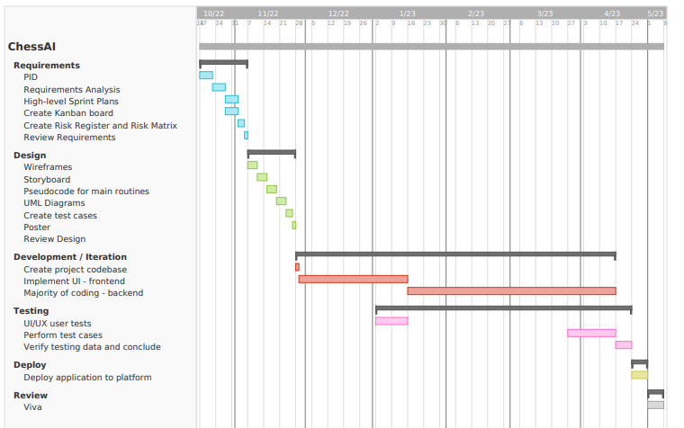

### **14.2 Risk Register and Assessment Matrix**

## 14.2.1 Risk Register

* All the following risks will have Responsibility assigned to the project Lead Developer.
* Detailed Mitigation and Contingency plans can be found on the GitHub repository [in progress].

|  |  |  |  |  |  |  |
| --- | --- | --- | --- | --- | --- | --- |
| **ID** | **Date Raised** | **Description** | **Category** | **Likelihood** | **Impact** | **Priority** |
| R1 | 20/10/2022 | User stories badly defined – scope too great, not concise. | Planning | High | High | High |
| R2 | 20/10/2022 | User stories prioritised incorrectly – main functionality is not the core focus. | Planning | High | High | High |
| R3 | 20/10/2022 | Test cases aren’t detailed enough. | Testing | High | Medium | Medium |
| R4 | 20/10/2022 | Documents / code stored on local storage becomes corrupted. | Technical | Low | High | Low |
| R5 | 20/10/2022 | Unplanned work – requirements are identified later within the project. | Planning / Development | High | Medium | Medium |
| R6 | 20/10/2022 | Technical issues preventing code/documents to be pushed to remote repository. | Technical | Low | Low | Low |
| R7 | 20/10/2022 | Lead developer unable to attend bi-weekly meetings. | Schedule | Low | Medium | Low |
| R8 | 20/10/2022 | Project supervisor is unavailable. | Schedule | Low | Low | Low |
| R9 | 20/10/2022 | Behind on schedule – deadline has passed but deliverable is not complete. | Planning / Schedule | Medium | High | Medium |
| R10 | 20/10/2022 | Lead developer has insufficient knowledge on relevant subjects. | Planning / Development | High | Low | Low |
| R11 | 30/01/2023 | Assignment deadlines for other modules are approaching and conflict with sprints. | Planning / Schedule | High | High | High |
| R12 | 30/01/2023 | Project member is having personal life difficulties and finding it hard to focus on or start on sprint items. | Personal | High | High | High |
| R13 | 30/01/2023 | Vacations are upcoming and may conflict with sprints. | Planning / Schedule | High | Medium | Medium |
| R14 | 30/01/2023 | Unknown assessment dates stop planning decisions from being made effectively, with justification. | Planning / Schedule | High | High | High |
| R15 | 30/01/2023 | Changes to technology being used; technology needed is not well defined. | Technology | Medium | High | Medium |
| R16 | 30/01/2023 | No access to computer so can’t work on code. | Technical | Low | High | Low |
| R17 | 30/01/2023 | No access to computer so can’t work on documentation. | Technical | Low | Medium | Medium |

## 14.2.2 Risk Matrix

* Find additional information about each risk by finding corresponding ID within the Risk Register.

|  |  |  |  |  |  |  |  |  |  |  |
| --- | --- | --- | --- | --- | --- | --- | --- | --- | --- | --- |
|  | | Impact | | | | | | | | |
| Low | | | Medium | | | High | | |
| Likelihood | High | **R10** |  |  | **R3** | **R5** | **R13** | **R1** | **R2** | **R11** |
|  |  |  |  |  |  | **R12** |  |  |
|  |  |  |  |  |  |  |  |  |
| Medium |  |  |  |  |  |  | **R9** | **R15** |  |
|  |  |  |  |  |  |  |  |  |
|  |  |  |  |  |  |  |  |  |
| Low | **R6** | **R8** |  | **R7** | **R17** |  | **R4** | **R16** |  |
|  |  |  |  |  |  |  |  |  |
|  |  |  |  |  |  |  |  |  |

### **14.3 Requirements Analysis Document**

## 14.3.1 Stakeholders

|  |  |  |  |
| --- | --- | --- | --- |
| Stakeholder Interest and Impact Table | | | |
| **Stakeholder** | **Interests** | **Estimated Project Impact** | **Estimated Priority** |
| End-users | Use application to improve at chess.  Use application for entertainment. | High +  High + | 1 |
| Project Supervisor(s) | Ensure project is on track.  Provide advice to primary stakeholders. | High +  High + | 5 |
| Project Manager(s) | Improve soft skills.  Expand project management knowledge.  Make sure deadlines are met. | Medium +  Medium +  High ? | 3 |
| Project Owner(s) | Improve soft skills.  Ensure prototypes meet user needs. | Medium +  High + | 4 |
| Project Developer(s) | Improve hard skills, expand technologies.  Expand project portfolio.  Ensure code is not buggy. | Medium +  Low +  High + | 2 |

Within the *Stakeholder Interest and Impact table* it is identified that the end-user is the most important stakeholder – this is because they are the ones that will interact with prototypes throughout the delivery of the project, and they are the target audience for the completed chess application.

## 14.3.2 Technology

|  |  |  |
| --- | --- | --- |
| Minimum Viable Product (MVP) | | |
| **Item** | **Category** | **Justification** |
| Python 3 | Language | Has many open-source libraries and tools that make implementing AI and Machine Learning easier. |
| Javascript | Language | Implement the interactivity of the web app. Frontend development. |
| HTML  CSS | Language | Used to implement the structure/design of the web pages. How content is displayed. Necessary for web development. |
| Flask | Web app framework | Very lightweight, compared to its alternative Django. Flask is one of the most popular web-app frameworks – lots of support and increase employability. |
| Atom | IDE / text editor | Easy to use, easy to configure, GitHub integration, multiple files open at once, open projects. |
| GitHub | Repository | Store documentation and code online within Cloud storage. Easy to access and maintain – version control. |
| SQL Server | Database | Industry standard relational database management system. Vast number of resources, and lead developer already has experience. |
| Trello | Kanban | Kanban board used for project management - track tasks. |

## 14.3.3 High Level Requirements

Functional requirements describe features and system behaviour. The end-user should be able to use these features to perform specific actions. On the other hand, non-functional requirements identify criteria that the system can be judged upon – often to describe a systems capability.

**Functional Requirements**

|  |  |
| --- | --- |
| **No.** | **Description** |
| 1 | User can play Chess against an AI. |
| 2 | User can choose to start with White or Black pieces. |
| 3 | User can select difficulty range of AI. |
| 4 | User can see their personal win rate against AI. |
| 5 | User can see statistical analysis at the end of each match. |
| 6 | User can select match type (rapid, blitz). |
| 7 | User can play against AI mimicking selected professional player. |
| 8 | User can Abandon or Surrender the game (counts as loss). |
| 9 | User can view history of previous games played. |
| 10 | User can create profile or be a guest visitor. |
| 11 | Application will be a Single Page Web Application. |
| 12 | Application will have homepage. |
| 13 | Application will have login / create account page. |
| 14 | Application will have Play Chess page. |
| 15 | Application will have profile page. |
| 16 | Profile will display username, picture, statistics, match history, badges. |
| 17 | User can earn Achievements/Badges by beating AIs at different ratings. |
| 18 | Database will store user profile information. |
| 19 | Database will store user login information. |
| 20 | Application will be accessible via desktops. |
| 21 | Application will be accessible via smartphone. |
| 22 | Strong password checking when creating account. |
| 23 | Application locks user out when they attempt too many incorrect logins. |

**Non-Functional Requirements**

|  |  |
| --- | --- |
| **No.** | **Description** |
| 1 | Application must be accessible and online 24/7. |
| 2 | Application will be native English. |
| 3 | Application should support hundreds of people accessing it at the same time. |
| 4 | Pages should load within 5 seconds. |
| 5 | Customer should log in within 10 seconds. |
| 6 | Customer should be locked out after 5 invalid login attempts. |

## 14.3.4 User Stories

|  |  |
| --- | --- |
| As a **General User…** | I want to play chess on my smartphone so that I can play wherever I am (outside, in bed, on the sofa). |
| I want to play chess on my desktop/laptop so that I can have the match full screen. |
| I want to change the language of the application so that I can use it in my native languages. |
| I want to create a profile so that I can see all my statistics and match history in one place. |
| I want to customise my profile’s display name and profile picture so that my profile is personalised. |
| I want to be able to share my profile with other people so that they can my statistics. |
| I want to make my profile private so that only I can see it. |
| I want to play as a guest so that I can remain anonymous and don’t have to create an account or sign in. |
| I want to unlock badges and display them on my profile, so that I can show off my achievements and progress. |
| I want to change and update my password so that my account is secure. |

|  |  |
| --- | --- |
| As a **person with a disability…** | I want to use my screen reader so that I can read the text on the screen because I have a visual impairment. |
| I want to be able to change the colour of the chess board and/or pieces so that I can differentiate them because I am colour blind. |
| I want to be able to navigate the website using keyboard because I have a motor disability. |
| I want to be able to play chess matches using algebraic input so that I can use my keyboard instead of my mouse because I have a motor disability. |
| I want to input my chess moves using my voice because I have a motor or vision disability. |

|  |  |
| --- | --- |
| As a **Chess Player…** | I want to drag and drop chess pieces to make my moves on a graphical interface so that the app is more interactive and entertaining. |
| I want to learn new openings so that I can improve at the game. |
| I want to choose to start with white or black pieces, so that I can practice different openings. |
| I want to select the rating of my opponent, so that I can train against easier or harder opponents. |
| I want to view my personal statistics such as win rate so that I know if I am improving or not, and gain confidence to keep playing chess. |
| I want to review a match that I just played, so that I can see where I made mistakes/blunders. |
| I want to select and play different match types (bullet/blitz/rapid), so that I can play either short or long games. |
| I want to play against chess professionals, so that I can challenge myself. |
| I want to abandon the match, so that I can stop playing and do something else, or because I feel like the game is lost. |
| I want to view my match history so that I can review past games / see if I’m on a loss or win streak. |

*1. The persona General User has been explicitly identified as their needs/desires are not solely those of a Chess Player and could reflect the wants of a user that has no idea what Chess is.*

*2. Chess Players could have been further decomposed into Beginners and Experienced, however they share the same goal: to improve at the game, and therefore their needs are similar.*

## 14.3.5 MoSCoW Prioritisation

|  |  |
| --- | --- |
| **MUST** | I want to play chess on my desktop/laptop so that I can have the match full screen. |
| I want to create a profile so that I can see all my statistics and match history in one place. |
| I want to customise my profile’s display name and profile picture so that my profile is personalised. |
| I want to be able to share my profile with other people so that they can my statistics. |
| I want to make my profile private so that only I can see it. |
| I want to play as a guest so that I can remain anonymous and don’t have to create an account or sign in. |
| I want to change and update my password so that my account is secure. |
| I want to use my screen reader so that I can read the text on the screen because I have a visual impairment. |
| I want to drag and drop chess pieces to make my moves on a graphical interface so that the app is more interactive and entertaining. |
| I want to learn new openings so that I can improve at the game. |
| I want to choose to start with white or black pieces, so that I can practice different openings. |
| I want to select the rating of my opponent, so that I can train against easier or harder opponents. |
| I want to view my personal statistics such as win rate so that I know if I am improving or not, and gain confidence to keep playing chess. |
| I want to review a match that I just played, so that I can see where I made mistakes/blunders. |
| I want to select and play different match types (bullet/blitz/rapid), so that I can play either short or long games. |
| I want to abandon the match, so that I can stop playing and do something else, or because I feel like the game is lost. |
| I want to view my match history so that I can review past games / see if I’m on a loss or win streak. |
| **SHOULD** | I want to unlock badges and display them on my profile, so that I can show off my achievements and progress. |
| I want to be able to change the colour of the chess board and/or pieces so that I can differentiate them because I am colour blind. |
| I want to be able to navigate the website using keyboard because I have a motor disability. |
| I want to be able to play chess matches using algebraic input so that I can use my keyboard instead of my mouse because I have a motor disability. |
| I want to play against chess professionals, so that I can challenge myself. |
| **COULD** | I want to play chess on my smartphone so that I can play wherever I am (outside, in bed, on the sofa). |
| I want to change the language of the application so that I can use it in my native languages. |
| I want to input my chess moves using my voice because I have a motor or vision disability. |
| **WONT** |  |

## 14.3.6 Product Backlog

|  |  |  |  |
| --- | --- | --- | --- |
| **Date** | **Component** | **Item** | **Priority** |
| 15/11/22 | Accessibility | I want to play chess on my desktop/laptop so that I can have the match full screen. | High |
| 15/11/22 | Accessibility | I want to play chess on my smartphone so that I can play wherever I am (outside, in bed, on the sofa). | Low |
| 15/11/22 | Accessibility | I want to use my screen reader so that I can read the text on the screen because I have a visual impairment. | High |
| 15/11/22 | Accessibility | I want to change the language of the application so that I can use it in my native languages. | Low |
| 15/11/22 | Accessibility | I want to input my chess moves using my voice because I have a motor or vision disability. | Low |
| 15/11/22 | Accessibility | I want to be able to change the colour of the chess board and/or pieces so that I can differentiate them because I am colour blind. | Medium |
| 15/11/22 | Accessibility | I want to be able to navigate the website using keyboard because I have a motor disability. | Medium |
| 15/11/22 | Accessibility | I want to be able to play chess matches using algebraic input so that I can use my keyboard instead of my mouse because I have a motor disability. | Medium |
| 15/11/22 | Accessibility | I want to drag and drop chess pieces to make my moves on a graphical interface so that the app is more interactive and entertaining. | High |
| 15/11/22 | Account | I want to create a profile so that I can see all my statistics and match history in one place. | High |
| 15/11/22 | Account | I want to play as a guest so that I can remain anonymous and don’t have to create an account or sign in. | High |
| 15/11/22 | Account | I want to change and update my password so that my account is secure. | High |
| 15/11/22 | Profile | I want to customise my profile’s display name and profile picture so that my profile is personalised. | High |
| 15/11/22 | Profile | I want to be able to share my profile with other people so that they can my statistics. | High |
| 15/11/22 | Profile | I want to make my profile private so that only I can see it. | High |
| 15/11/22 | Profile | I want to view my personal statistics such as win rate so that I know if I am improving or not, and gain confidence to keep playing chess. | High |
| 15/11/22 | Profile | I want to unlock badges and display them on my profile, so that I can show off my achievements and progress. | Medium |
| 15/11/22 | Match history | I want to view my match history so that I can review past games / see if I’m on a loss or win streak. | High |
| 15/11/22 | Matchmaking | I want to choose to start with white or black pieces, so that I can practice different openings. | High |
| 15/11/22 | Matchmaking | I want to select the rating of my opponent, so that I can train against easier or harder opponents. | High |
| 15/11/22 | Matchmaking | I want to select and play different match types (bullet/blitz/rapid), so that I can play either short or long games. | High |
| 15/11/22 | Matchmaking | I want to abandon the match, so that I can stop playing and do something else, or because I feel like the game is lost. | High |
| 15/11/22 | Learn | I want to review a match that I just played, so that I can see where I made mistakes/blunders. | High |
| 15/11/22 | Learn | I want to learn new openings so that I can improve at the game. | High |
| 15/11/22 | Design/Plan | Wireframes | High |
| 15/11/22 | Design/Plan | Storyboard | High |
| 15/11/22 | Design/Plan | UML Diagrams | High |
| 15/11/22 | Design/Plan | Risk Register and Matrix | High |
| 15/11/22 | Design/Plan | Technology poster | High |
| 15/11/22 | Design/Plan | Use-case scenarios | High |

### **14.5 Kanban Board**

## 14.5.1 Starting Board

### **14.5 Kanban Board**

## 14.5.1 Starting Board

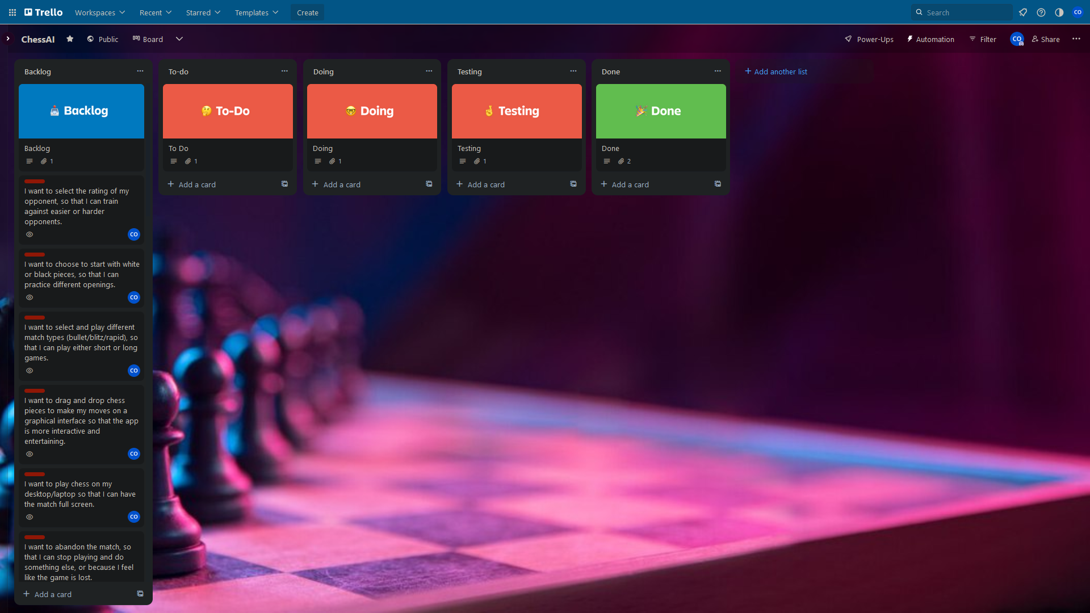

## 14.5.2 Chronological Progression of Boards

Implementing match control features.

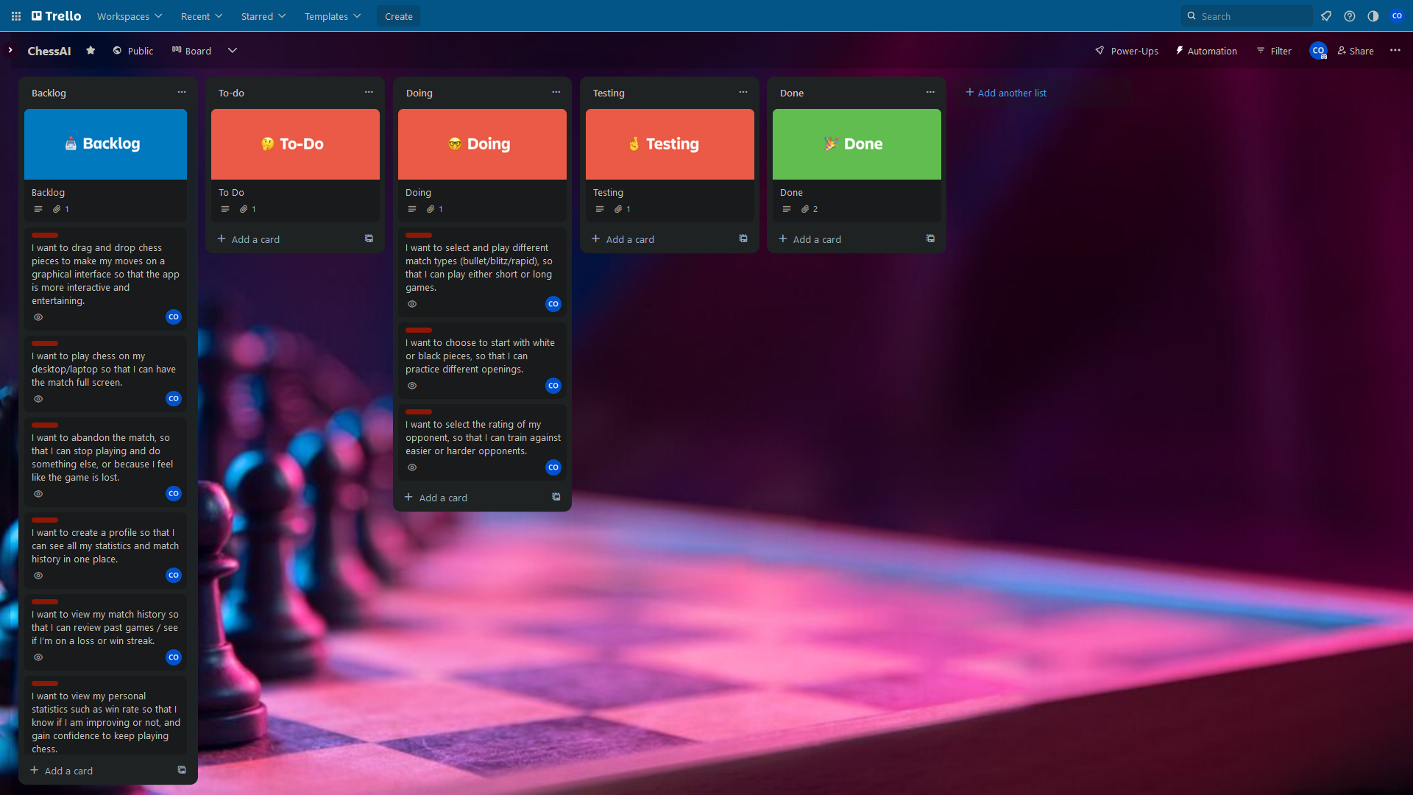

Gathering Chess game relevant items.

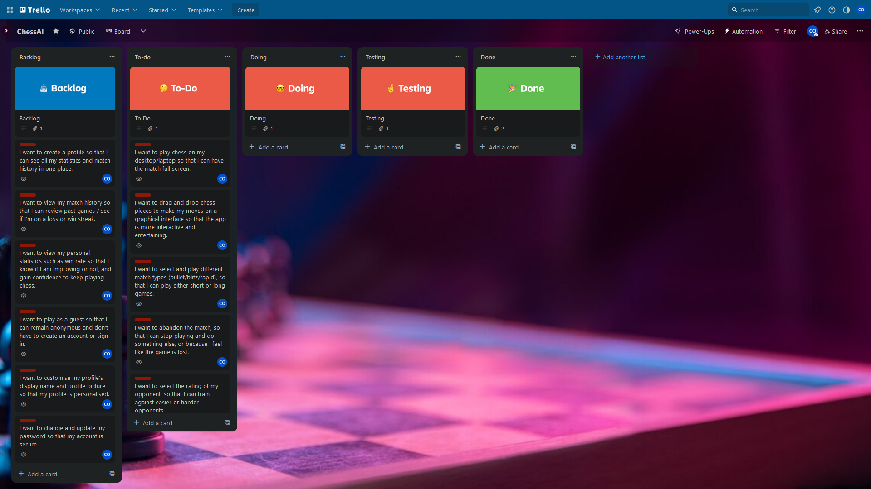

Implement match control features. Player can select Black or White. Player can select time control.

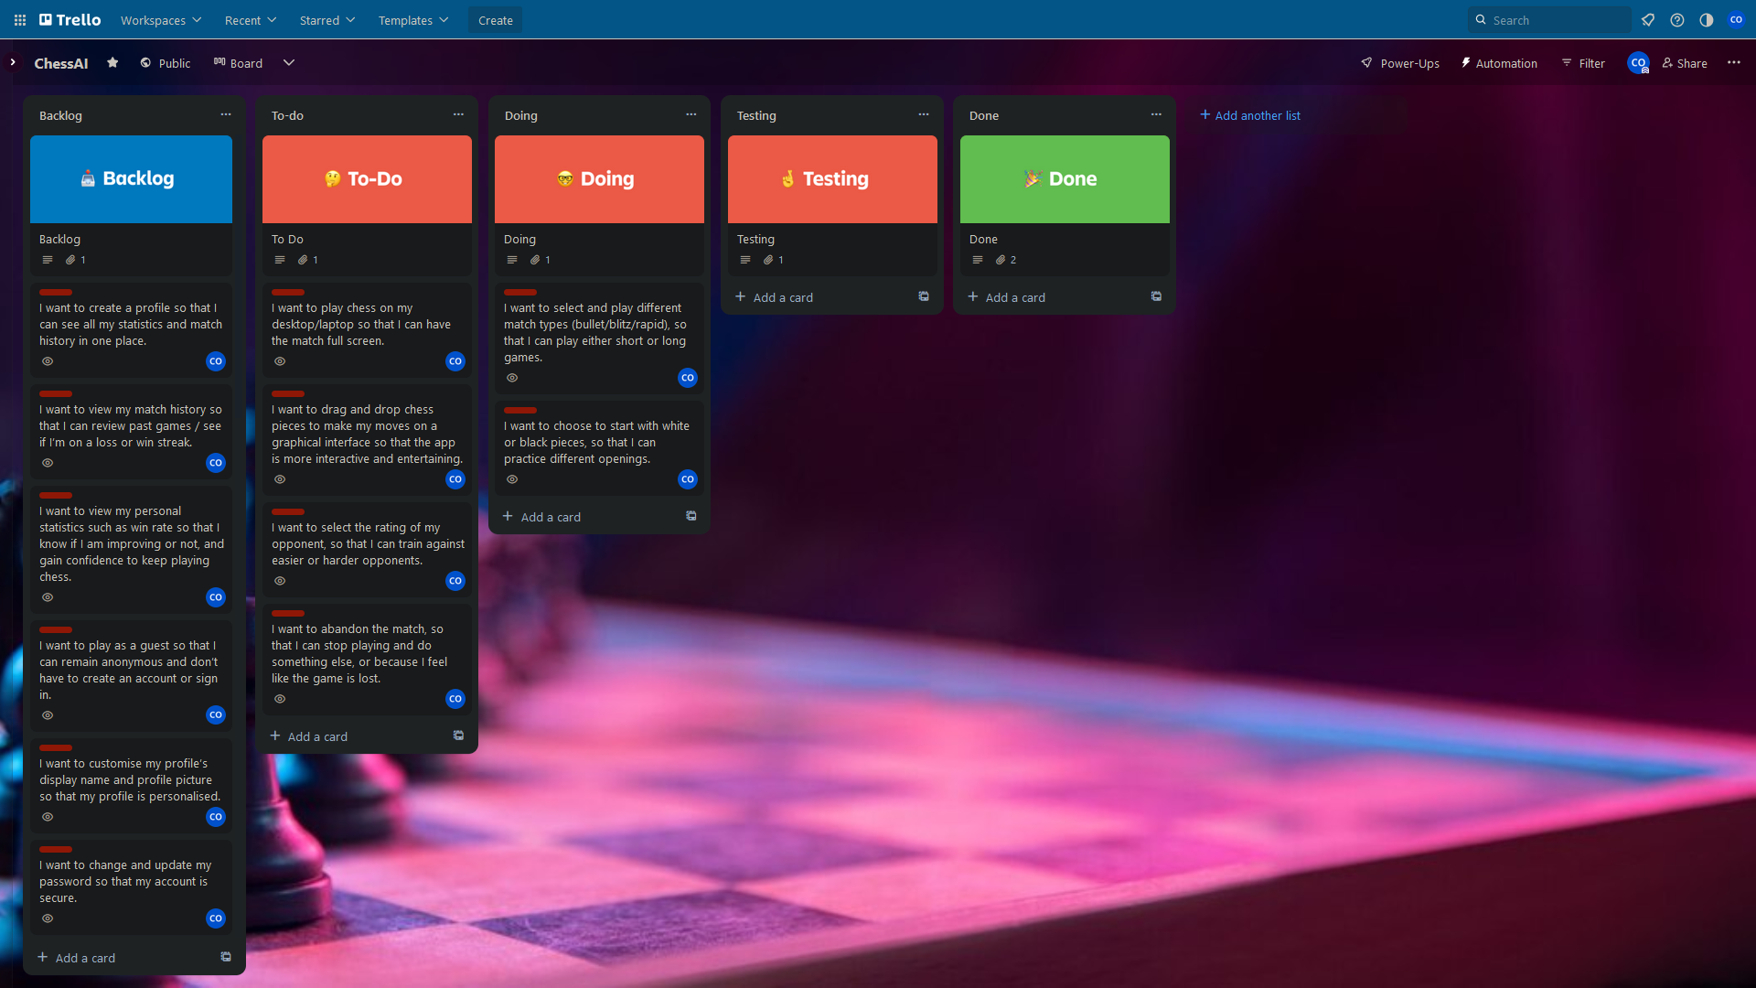

Testing Chess match control criteria.

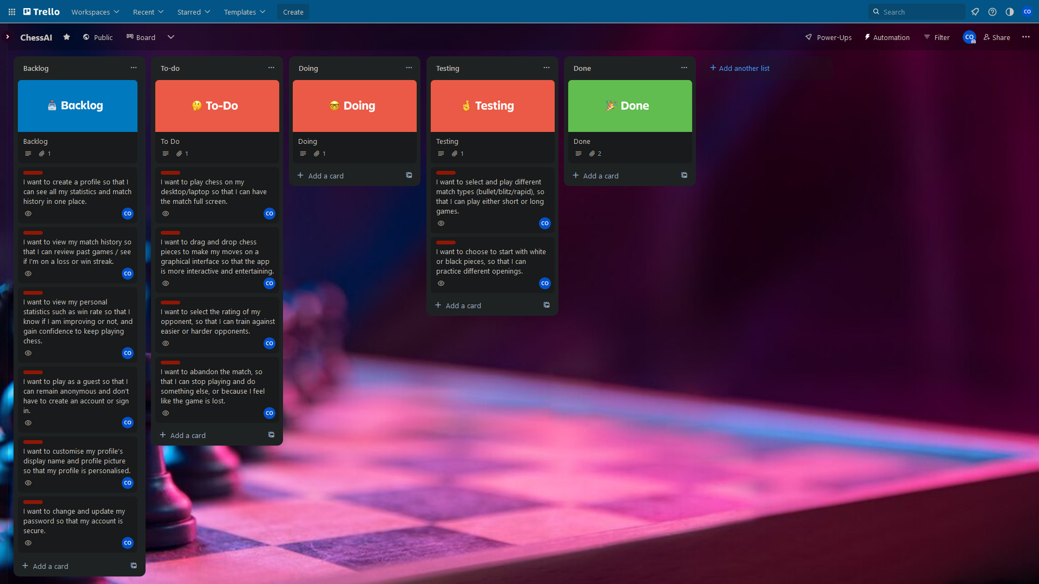

Match control done! Implementing profile creation/login/authentication.

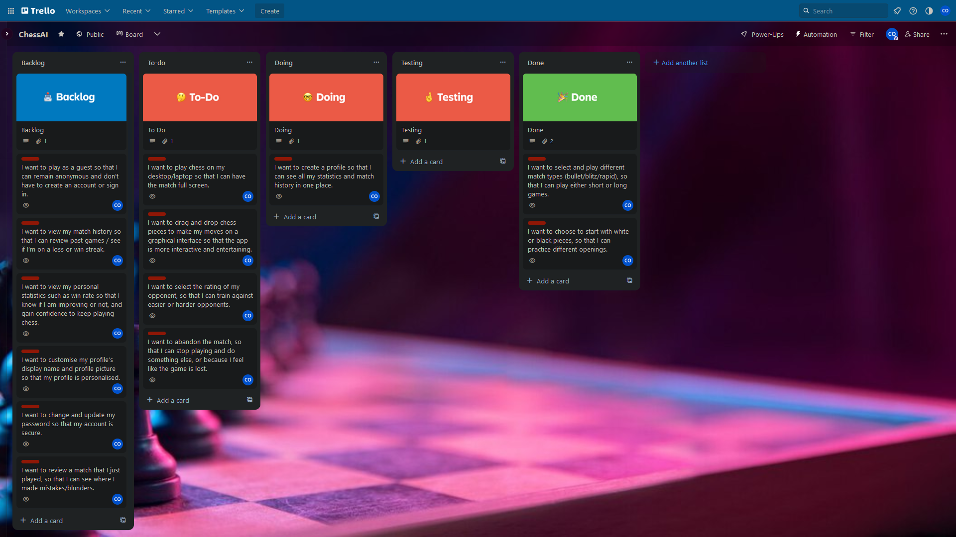

Testing authentication. Start implementing Chess frontend GUI.

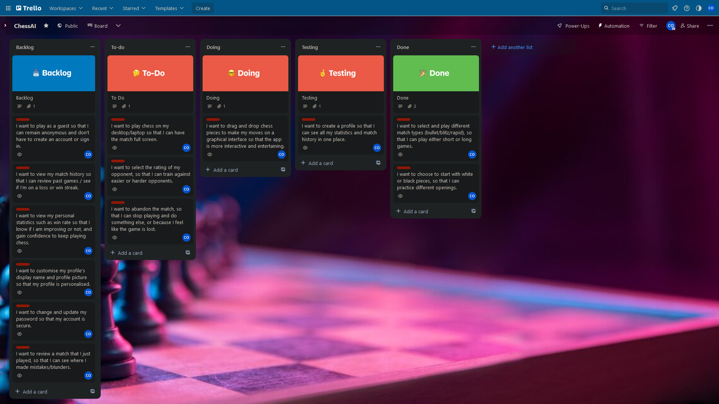

Testing GUI. Start implementing Chess backend and game state. Win/Lose/Draw/Resign.

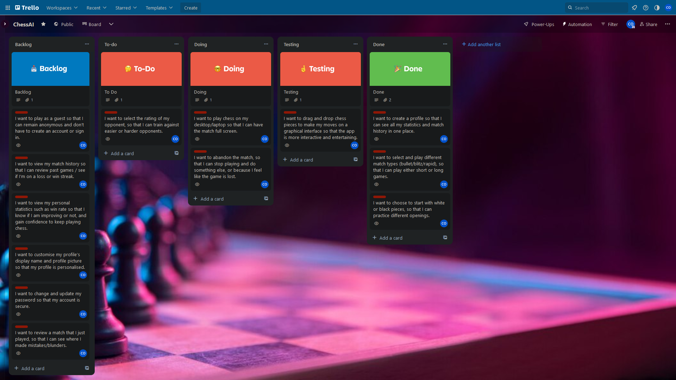

Developing AI opponent move. Meanwhile testing GUI and move validation.

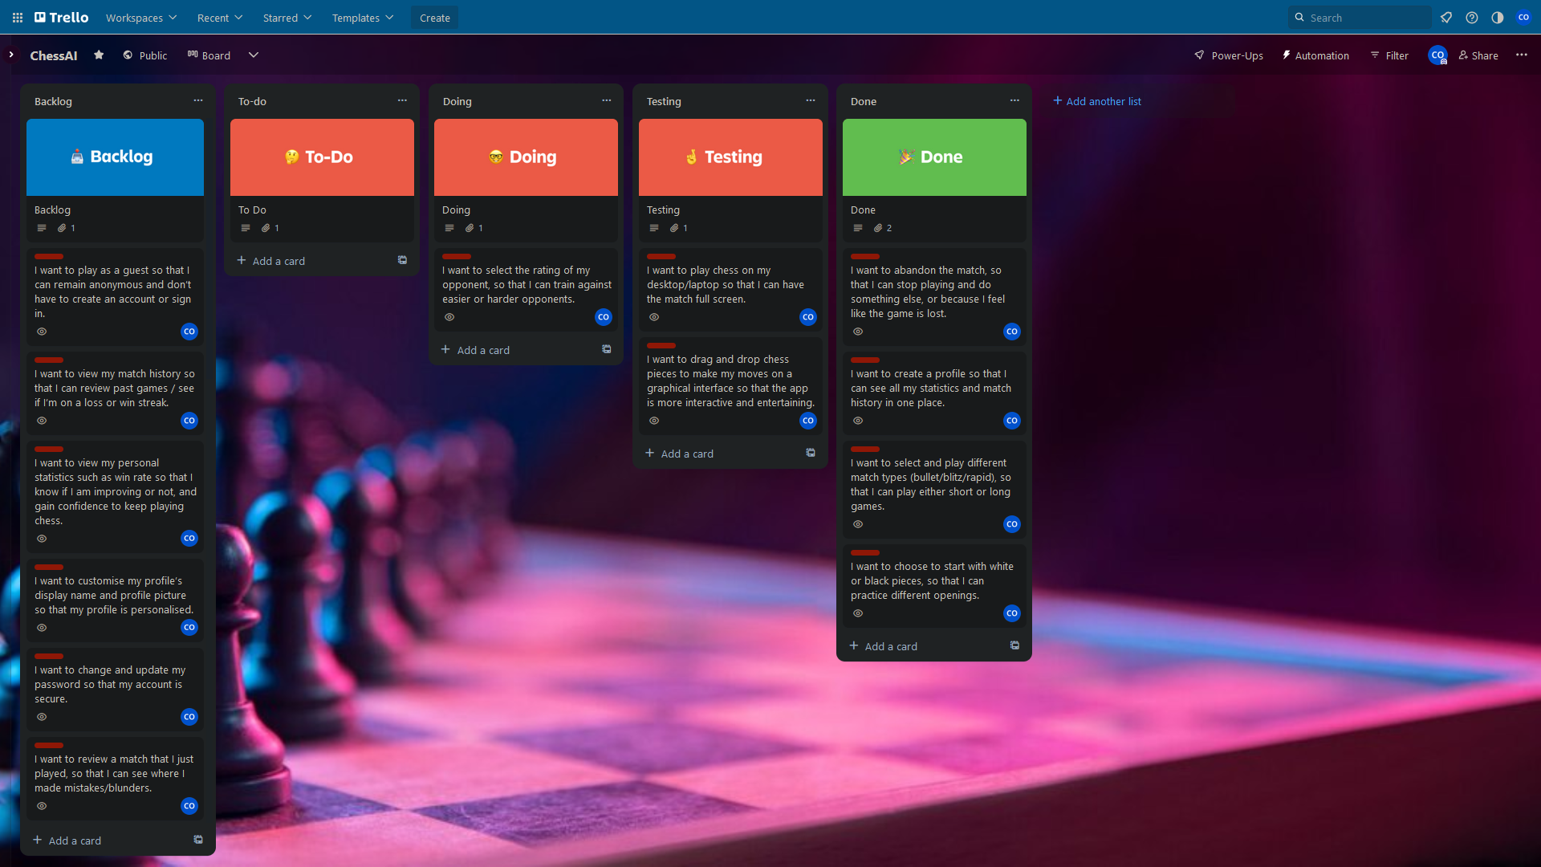

GUI and move validation correct. Checkmate etc working. Still working on AI.

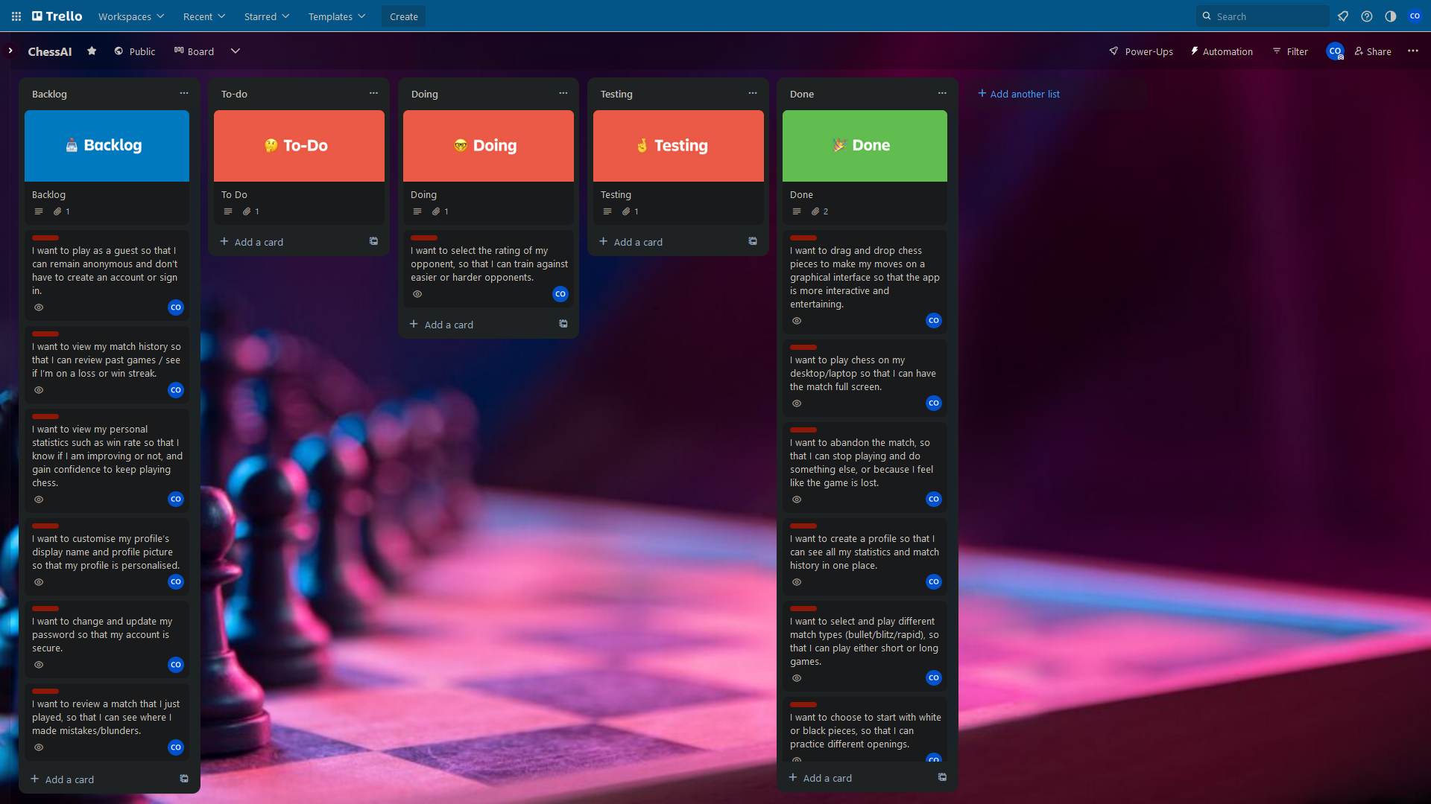

## 14.5.3 Final Board

AI opponents implemented.

